Day - 13
File Input And Output Method
Open() – to open a particular file.
Read() – reads entire file content.
Readline() – reads all line as a list.
Write() – writes data into file.
Writeline() – writes multiple lines into files.
Close() – closes the file.
Len() – returns the length of an object.
Range()- generates a sequence of numbers.
Print()- displays output on the screen.
Type() – returns the datatype of a value.
Id()- returns the unique memory address of an object.
Sorted()- returns a sorted list
Enumerate()- returns index and values pairs.
Zip()- combines multiple iterable into pairs
- Conversion functions.
- Mathematical functions.
- Class and object functions
- Memory and object management
Assignment – 3
The enumerate() function is a built-in Python utility that adds a counter to an iterable (like a list, tuple, or string) and returns the result as an enumerate object.
Simple program:
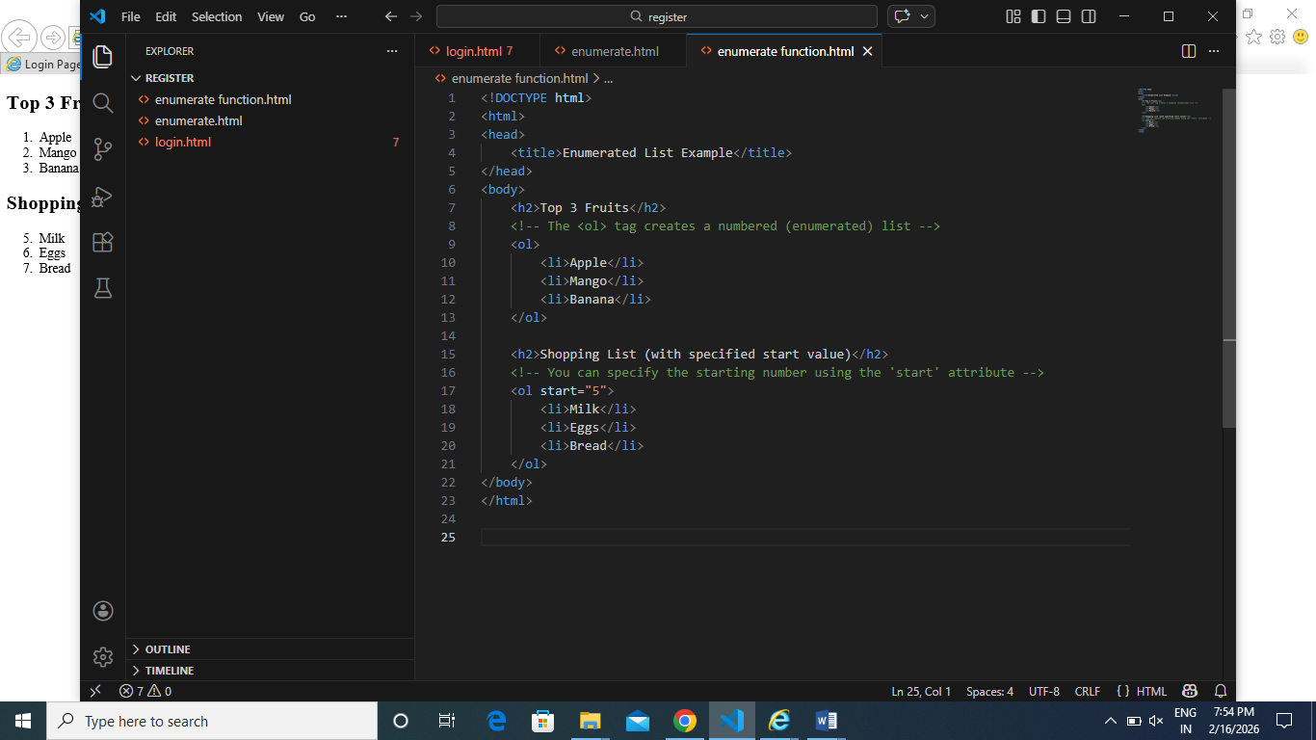

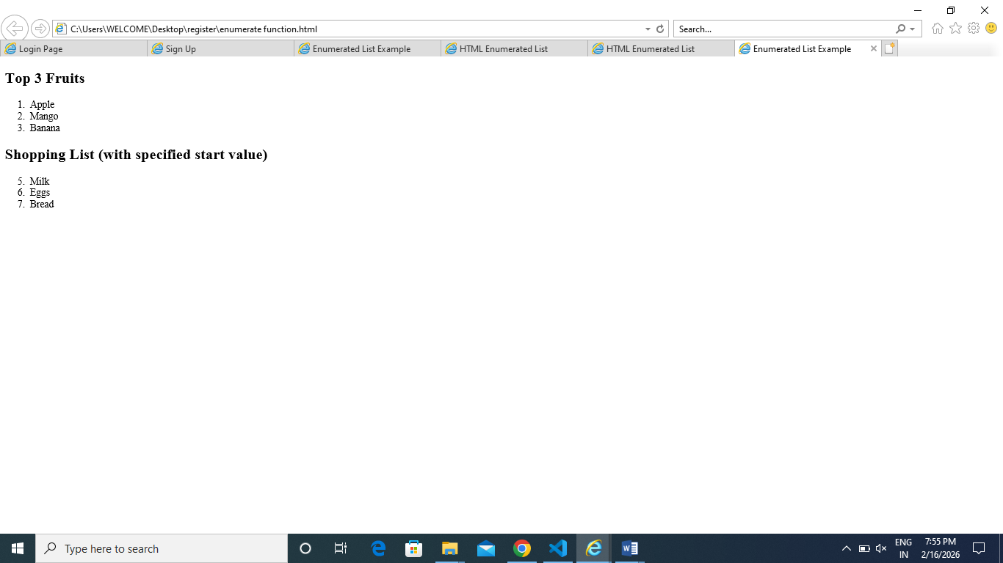
Day – 14
AI models
Stack over flow is a website which community of many programmers. How to solve the error. To train the gpt is one of the method is sof.
- Google – Gemini models
- OpenAI – GPT models
- Groq – ultra fast inference hardware+ Large Level Models
- Microsoft – copilot, azure, openAI services.
Large Level Models is model
Nlp is technique.
Rate limit is many request in a given time, request count. Deals with input. No request from nlp, no of request.
Token limit is one request, text or word count both input and output are calculated.
Chat completion role and content inside the content.
Openai Import openai Pip install openai
Gemini api key generation- api key – create- copy beside the dollar symbols
llama api key generation using groq- api keys – create api key-name
chatbot llm
DAY – 15
NLP – Natural Language Processing makes the machine to understand the human language.
It has a several process. The first step is collecting the data tap to return the data.
Prepare and engineering features – pre-processing step is prepare and training NLTK(natural language tool kit)
Key steps of NLTK
- Tokenization – makes the entire paragraph into sentences.
- Stop word removal - removes the common word which had no meaning ( is an, the).
- Stemming – cutting down into a meaning word. Playing is play
- Lemmatization –
- POS Tagging – part of speech tagging done by pronoun noun adverb
- NER – name entity recognition handles three name-place-date along with organization.
- Positive tagging and negative tagging - she is good/bad girl.
From nltk.tokenize import word_tokenize
From nlt.corpus import stopwords
From nltk.stem import PorterStemmer
From nltk.stem import WordNetLemmatizer
Nltk.download(‘words’)
Nltk.download(‘maxent_ne_chunker’)
ASSIGNMENT – 4
